## Prelim Pages

Version Control /Approval etc

## Introduction

Functionality to enable simple export and import of data reduces the labour and intensity of managing these processes manually. This chapter discusses the processes in detail.

## Execution Data Cycle

Data is moved between the sheet and the test tool in a cyclic fashion while there are executions to perform on a target system. The cycle is simply exporting to and importing from, when there is data to collect from an execution. Figure 1 depicts the general data cycle process.



Figure

A caveat to this cycle occurs when the test tool fails to write results for use. This situation is discussed in detail in Chapter 7.

## Export

Export functionality is controlled from the ribbon with the buttons in Figure 2 below.

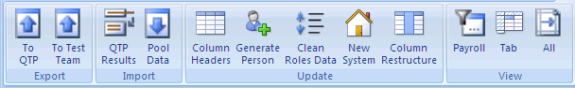

Figure

Export has three functions within the two buttons:

* Export to Test Tool (QTP)
* Export to Test Team as:
  + Testers (Formatted)
  + All (Unformatted)

Discussions on each are in reference to Figure 1 above.

### Test Tool

All the data, including the headers is exported to a sheet the test tool can access. The process is completely automated, including naming of the file. The workflow is:

* Select the data set identifier in the dialog in Figure 2 below,
* Click OK to export.

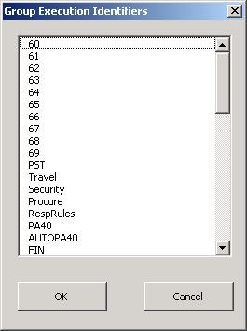

Figure

Clicking Cancel closes the dialog and no further action is taken.

Once exported, the user must move to the test tool user manual for instructions on accessing the exported data.

### Test Users

Clicking “To Test Team” displays Figure 4 below.

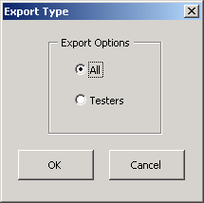

Figure

Select Testers for the formatted output to test users. On occasion, the testers require a custom format, eg they need personal data for their tests. All can be used to output the extra data and the engineer can manually trim the columns to suit the need on the generated output.

#### All (Unformatted)

Figure 5 below is a sample unformatted output. The copy is a “sheet-wise”, ie each sheet in the source data is copied to a sheet in the output or destination sheet.



Figure

#### Testers (formatted)

Figure 6 below example of the formatted output for Test Users. This can be altered by changing the coding and the header sheet (User Headers) in the master. The copy is “sheet-wise”.

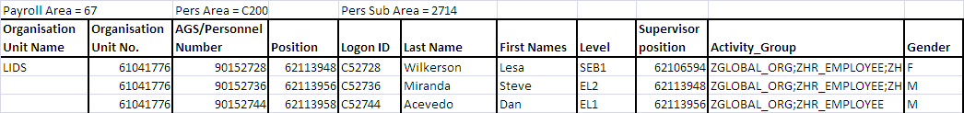

Figure – Sample Formatted output

## Import

Import has two functions:

* Import from test tool results,
* Import Data Pool.

### Test Tool Results

Results in most test tools are stored along with the “runtime” copy of the sheet used to provide the initial data pool. The user is presented with a standard Windows Folder Browser to locate the Results folder and click OK.

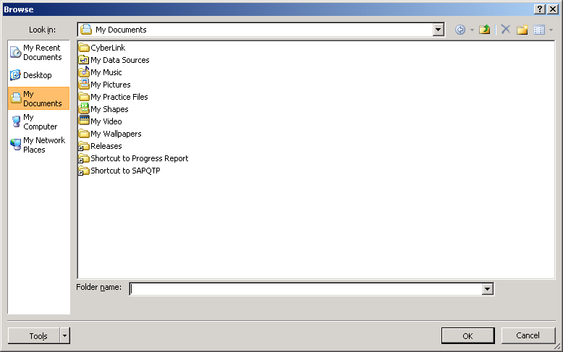

Figure

If the results are on an integrated server (eg Quality Centre) the user must download the results first.

### Data Pool

See User Manual Chapter 4 for details on this interface.

...oooOOOooo...